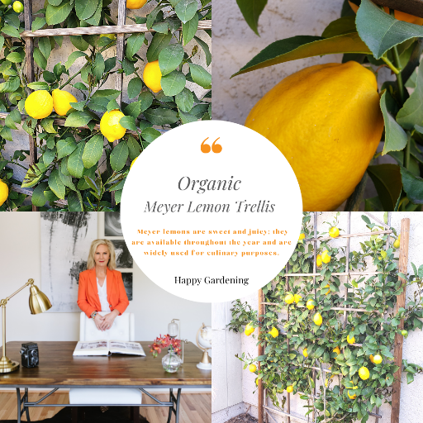
Dear Reader,
I hope every one of you are enjoying the beautiful Spring weather. On the first of the month, I had a chance to take a few days and head to Northern California for a work/family trip. The work part was to assist a fantastic client with listing their home in Petaluma. Yep, I'll help my clients anywhere they need me to go. The second part of the trip was celebrating my mother-in-law's 90th birthday in Danville. I don't know if you have ever headed north in the springtime, but wow, was it beautiful. The client in Petaluma is an avid organic grower. Honestly, I thought the lemons on her trellis were fake. But they were so perfect I wanted to share them in this month's picture so you could see them for yourself.
The "Best Of" or "Top 10 lists" and now "Vetted": Do these types of lists get your attention searching for something new to purchase? If so, here are a few from a new source I enjoy, "Vetted" by Forbes.
- The 12 Best Handheld Vacuums For Tackling Everyday Messes.
- The Tech Wrangler: Three Essential High-Tech Tools For About $30 Each
- 15 Of The Best Places To Buy Affordable Art Online
- New Puppy Checklist: Here's Everything You Need To Buy
- Everything You Need For A Backyard Movie Night, From Outdoor Projectors To Popcorn Machines
Please take a moment to investigate a new bill being proposed, AB 1771, the California Housing Speculation Act. This bill would, for taxable years beginning on or after January 1, 2023, impose an additional 25% tax on that portion of a qualified taxpayer's net capital gain from the sale or exchange of a qualified asset, as defined. The bill would reduce those taxes depending on how many years has passed since the qualified taxpayer's initial purchase of the qualified asset.
A few great homes I have just listed for sale:
10514 Mahoney, Shadow Hills beautiful horse property. $1,229,000
5721 Canyonside, La Crescenta Brand New 4 Bedroom house + 2 bedroom guest house. $2,200,000
You can view the entire letter and visit all the links at MyMonthlyLetter.com
Respectfully,
Robbyn Battles

