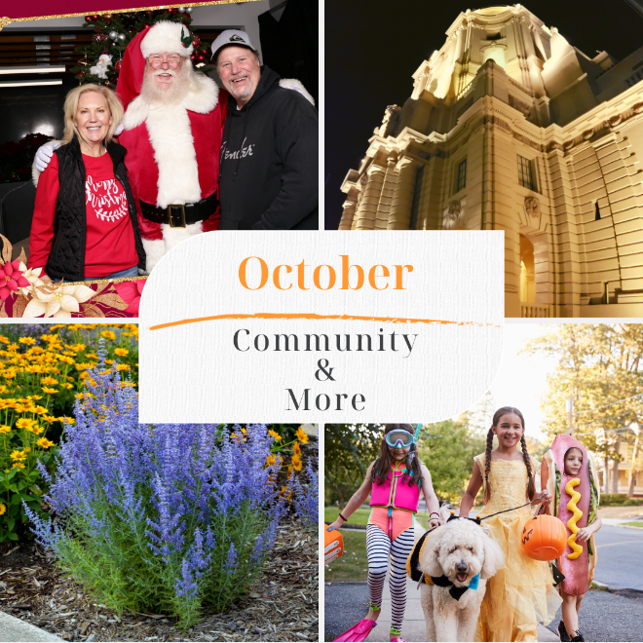

October 2022
John Doe
1234 You suck lane
Vacation Land CA 91214
Dear Joe,
You are invited!!! I'm hosting my second annual community holiday party, "FREE photos with Santa and Snow." This year I'm turning things up a notch with a live band, two snow sled lanes, a larger snow area, and lots of fun photos with Santa. More surprises to follow. Knowing December calendars fill up fast, reserve your FREE tickets now. Sunday, December 11th, 4:00 pm to 7:00 pm. 2428 Foothill Blvd., La Crescenta at the JohnHart Campus. Pets welcomed if they're on a leash. Here's the link info for tickets and more details. Robbyn.info/Santa
Now that we're in full swing for Fall. It's time to fall in love with water-saving California plants. With last month's 20-day no watering ban, this may just be what the yard doctor ordered. If you like purple, try some Mexican Bush sage. If you opt for White sage, you'll enjoy a beautiful aroma. Red is gorgeous for a Fall Garden, the little John dwarf bottlebrush is perfect, and hummingbirds adore this plant. Look at the entire list of plants, how to plant and maintain them. Robbyn.info/Fall
One of the most popular holidays in October, of course, is Halloween, and Montrose shopping park is back in full swing and will have its giant trick-or-treat event for the kids. Of course, adults feel free to get dressed up as well. While we're on the topic of Halloween, make sure you keep the candy and wrappers away from your dog. Find out what the six poisonous candies from Halloween are. Candy corn is on the list. Link to the list. Robbyn.info/Halloween
Have you heard about the high school senior making a cancer-detecting toothbrush? Find out how he was discovered and what type of funding he is getting to pursue his endeavor. Full article link, Robbyn.info/Toothbrush
Pasadena City Council votes to allow churches, synagogues, and mosques to develop affordable housing under a new zoning amendment because most religious institutions in the city are zoned for commercial use allowing no room for residential development. Bill proposal SB1336 would allow houses of worship to build affordable housing throughout the State regardless of the zoning. Details, Robbyn.info/SB1336
As the real estate market transitions, I encourage you to consult with me for information, options, and guidance to help you make the right decisions for yourself and your family.
Sincerely,
Robbyn Battles
View the entire letter with links at MyMonthlyLetter.com

